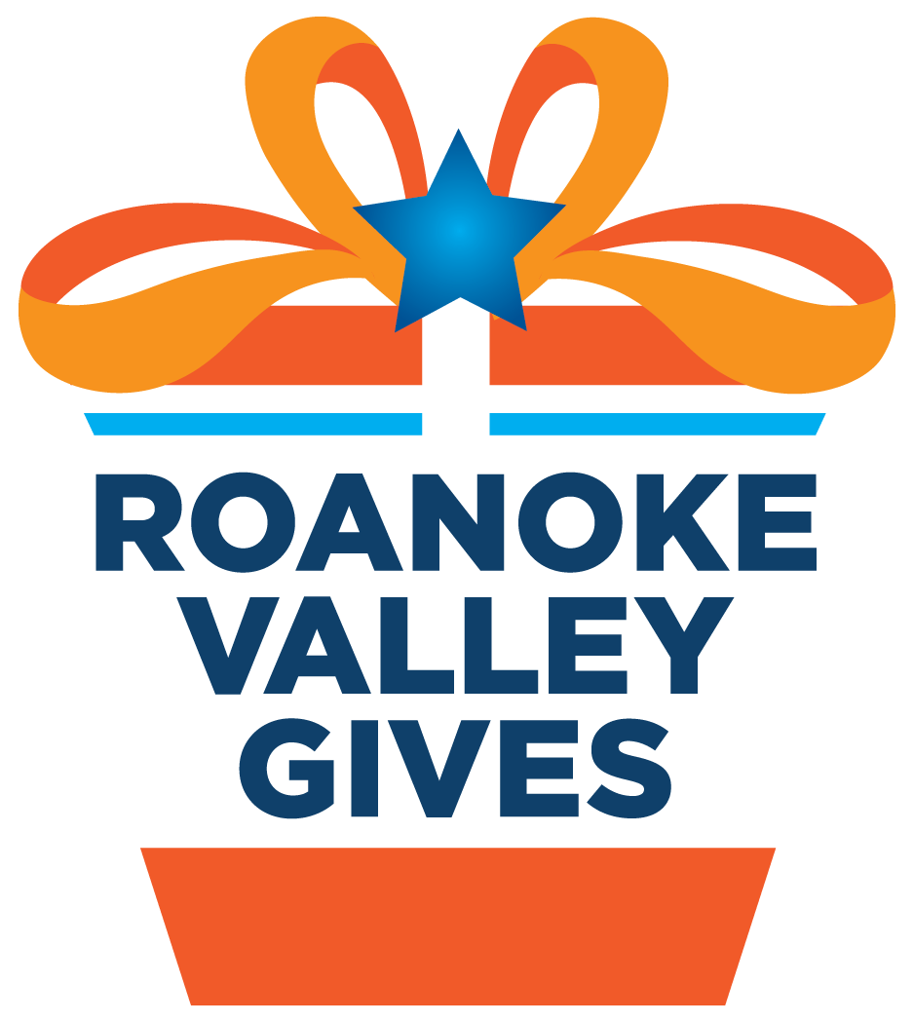
For Immediate Release
Contact: Carly Oliver, Chief Operating Officer, 540.985.0204, carly@cfwesternva.org
Roanoke Valley Gives is Back for a Fourth Year
Roanoke, VA (February 15, 2019) – Community Foundation Serving Western Virginia announced today that Roanoke Valley Gives, the first-ever valleywide online day of giving implemented in March 2016, will return. Nonprofits from all over the Roanoke Valley will come together for a fourth powerful day of action on Wednesday, March 13, 2019.

This innovative online fundraising event encourages Roanoke Valley residents to donate as much money as possible in support of their favorite local charities in just twenty-four hours. To date, 164 Roanoke Valley nonprofits have joined this year’s effort, with additional organizations in the process of registering.

Collectively in 2018, the organizations raised $740,004 with over 5,174 gifts received, with an average gift of $143. Building on that success and believing in the generosity of the community, the Foundation announced that the 2019 goal is $800,000.

Carly Oliver, Foundation COO, noted “Give days had proven to be quite successful in other communities across Virginia and the United States. Our goal is to help nonprofits raise significant amounts of dollars for their organization in a very short period of time, to expand their donor base, and to provide them with an online giving presence and professional social media and related technical training. We do this work soley to benefit this community we love, as the community foundation does not receive any fee income from the give day.”

To further entice organizations to participate, the Foundation has again raised tens of thousands of dollars in the form of sponsorships to be awarded as incentive prizes throughout the day, such as for the organizations that raise the most money. Poe & Cronk Real Estate Group is again the event’s Platinum Partner, and Davis H. Elliot Company, Advance Auto Parts, and Ginny Jarrett of Davenport & Company are the Gold Partners. More than two dozen other sponsors comprise the Silver, Bronze, Community Supporter, and Media sponsors. The Foundation indicated that it is still looking for additional sponsors for the day.

Roanoke Valley Gives will begin at midnight EST on March 13 and continue until 11:59 p.m. on that same day. Donors will go online to rvgives.givebig.org to connect with causes they care about and make tax-deductible donations to support the important work of their favorite Roanoke Valley nonprofits.

Community Foundation Serving Western Virginia is the community foundation serving this region. It has worked for 30 years to administer and make grants from hundreds of named endowment funds on behalf of the community. For more information, visit www.foundationforroanokevalley.org. Platinum Partner Poe & Cronk Real Estate Group is locally owned and internationally recognized as the region’s leading full-service commercial real estate company. ###

